Courgette, Banana and Lemon Cake
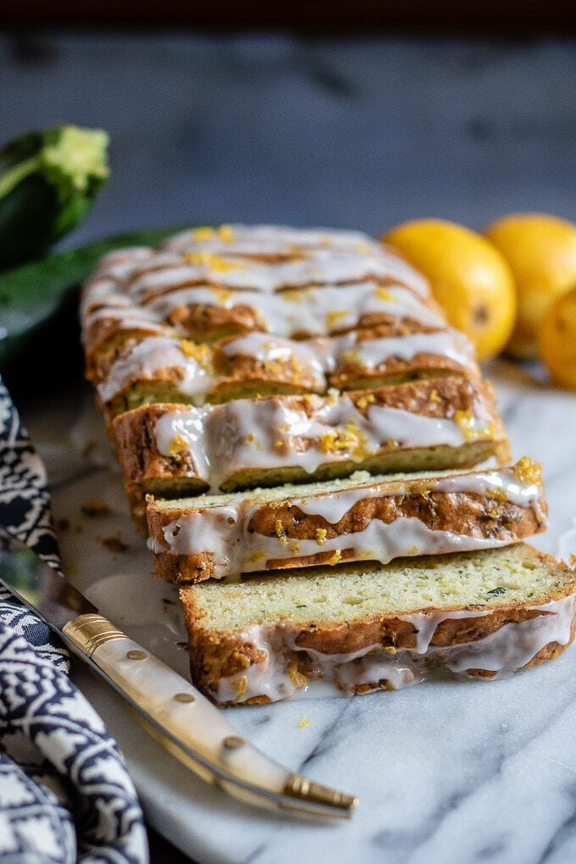
Ingredients:
- 2 Bananas
- 3 Eggs
- 5tbsp Honey
- 1 tsp Vanilla
- 75g Butter, softened
- 1 tsp Baking powder
- 2 medium Courgettes

Instructions:
- Preheat oven to30F/ !80C Gas ark 5.
- Line a 900g loaf tin or a 20 cm cake tin with non stick baking paper.
- Grate 2 small-medium courgettes into a colander (you need around 350g grated courgette) and use your hands to squeeze out as much excess water as possible. Leave in the colander and set aside.
- Mash bananas in a large mixing bowl. Beat in butter, eggs, honey and vanilla extract. Beat until well mixed.
- Sift the flour and baking powder. Fold the mixture together.
- Add the grated courgette and lemon zest. Stir gently.
- Pour into the prepared loaf/ cake tin and bake for 45 minutes until firm to the touch and a skewer inserted in the centre comes out clean.
- Leave in the tin to cool completely.

Tips and Suggestions:

To ice:
- Once the cake is completely cool mix together 175g sifted icing sugar with 2 tbsp lemon juice. Pour over the cake and decorate with grated lemon zest if desired. Leave to set.
- Store in an airtight container in a cool place.

Egg Allergy:
To make two flax eggs mix 2 tbsp ground flax seed (linseed) with 5 tbsp cold water. Set aside until you have a gloopy mixture.

