Wild Garlic Pesto
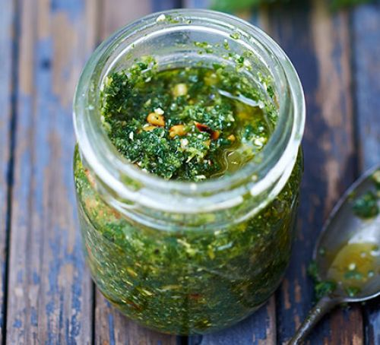

Ingredients:
- 150g wild garlic leaves or young nettles, or a mixture
- 50g parmesan or vegetarian alternative, finely grated
- 1 garlic clove, finely chopped
- ½ lemon, zested and a few squeezes of juice
- 50g pine nuts, toasted
- 150ml rapeseed oil

Instructions:
- Rinse and roughly chop the wild garlic leaves.

- Blitz the wild garlic leaves, parmesan, garlic, lemon zest and pine nuts to a rough paste in a food processor.

- Season, and with the motor running slowly, add almost all the oil.

- Taste, season and add a few squeezes of lemon juice.

- Transfer the pesto to a clean jar and top with the remaining oil.

Enjoy!

Tips and suggestion:

USing NETTLES?
If you're making this pesto with nettles, bring a large pan of water to the boil, then drop in the nettles and cook for 2 mins. Drain and run under cold water, then squeeze out as much water as possible before roughly chopping them and adding to the food processor as above.
Not Suitable for Pregnant women

