Colour Sorting Game for Toddlers
Resources Needed
4 COLOURED A4 PAPER (YELLOW, BLUE, GREEN AND RED)
Or fabric or boxes that are yellow, one red, one green and one blue
You can start with just 2 colours at first.
Different coloured toys and objects.
Basket/box or just empty container

Instructions
Put all the objects in the container.
Put all the paper or fabric on the floor.
Children sort the objects and match them to coloured paper.

This is a problem solving activity and also children can learn about colours in a fun and exciting way.
Sorting and Matching are also skills needed for Maths.
It is also a chance to develop hand /eye coordination and fine motor skills too.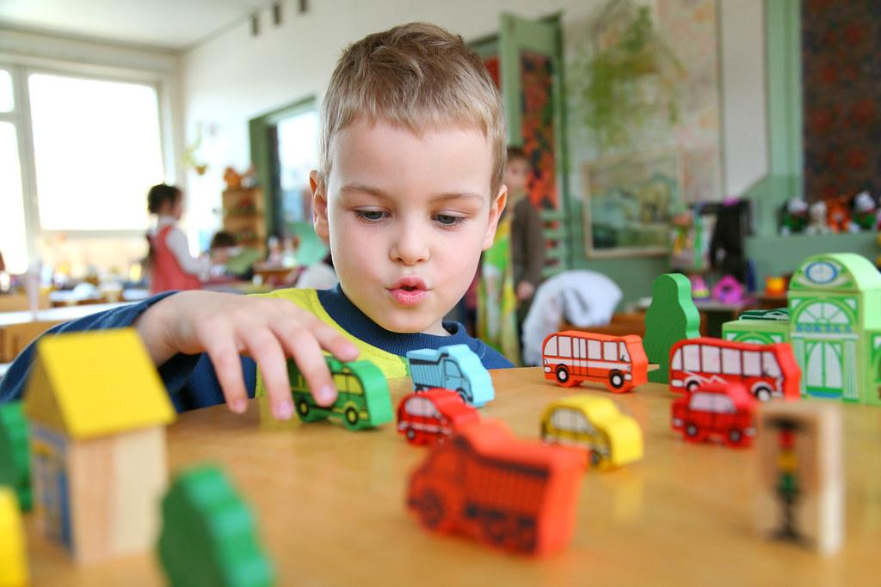 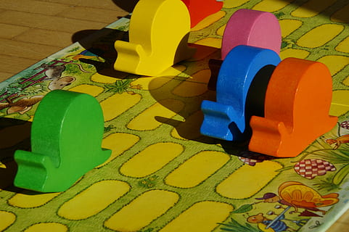
Young children will enjoy the challenge and it is not important that they get everything right as they are very young, but they will start to know colours that are the same and those that are different.
