Sugar Free Chocolate Cookies

Ingredients:
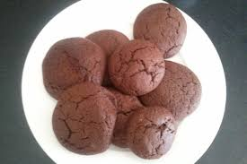
- 350g Plain flour
- 100g Cocoa powder
- 250g Soft margarine
- 1 tsp baking soda
- A pinch of salt
- 2 Eggs
- 3 tbsp sugar free strawberry jam
Instructions:
- Preheat your oven to 180 C/350 F/gas mark 4.
- Take your strawberry jam and cream in a large bowl with your margarine, until light and fluffy.
- Beat your eggs and stir into your margarine and jam.
- Sieve your plain flour and bicarbonate of soda and mix until you have a good chocolatey dough.
- Dust a surface with flour and roll your dough out. Using a circular cookie cutter, cut into round shapes. Place on a greased baking sheet and position in the centre of your oven.
- Bake for about 15 minutes.
- Remove from oven and allow to cool.

Enjoy!

Tips and Suggestions

No cutter? No Worries! Try using a cup/glass to cut out shapes or trying to cut different shapes with a knife.

